Module Six Assignment – UML Diagrams/Analysis
APA

Cynthia Turner
Southern New Hampshire University
CS-255: Module Six Assignment
Professor Denise Washington
Oct 11, 2026

This analysis interprets the supplied UML activity and sequence diagrams for an ATM cash withdrawal and evaluates how the design could be made safer and more complete. The revised activity diagram focuses on validating the transaction before cash is dispensed and on giving the user and bank clear outcomes when a transaction cannot be completed.
Diagram Interpretation
The diagrams describe the ATM cash withdrawal use case. The activity diagram shows the overall workflow: the user begins by entering a card and PIN, the system determines whether the PIN is correct, the user enters a withdrawal amount, and the ATM either dispenses cash and prints a receipt or ends the transaction when a PIN is wrong or the amount is unavailable. The sequence diagram shows the same process from an interaction viewpoint. The user sends the card, PIN, and requested amount to the ATM; the ATM asks for the PIN and amount and communicates with the bank to verify the PIN. The bank returns a PIN-valid response, after which the ATM returns the requested cash to the user. In this exchange, the information passed between the user and ATM is the card, PIN, amount, prompts, and cash, while the ATM and bank exchange the PIN verification request and the validation response.
Design Analysis and Proposed Improvements
The current design communicates the basic happy path, but it leaves important logic and functionality undefined. The following improvements would make the ATM safer, more reliable, and easier for users to understand:
PIN security and retry handling: The design identifies a wrong PIN but does not show a retry limit, card retention, temporary lockout, or a user message. The ATM should allow a limited number of attempts and then terminate the session or retain the card according to bank policy.
Authorization, balance, and withdrawal limits: The design verifies the PIN but does not show the bank authorizing the requested amount, checking available funds, or enforcing daily withdrawal limits. The ATM should receive an authorization response before dispensing cash and should show a clear decline reason when the request is not approved.
Cash-dispense verification and recovery: The design assumes that cash is dispensed successfully. It should verify that the dispenser delivered the requested amount and define a recovery path for a partial dispense, empty cassette, jam, or communication failure. The bank should be able to reverse or flag an incomplete transaction.
Completion and security steps: The design does not clearly show returning the card, ending the session, or clearing sensitive information from the ATM. These steps should occur after completion or failure so the next customer cannot access the prior session.
Selected Improvement
The reconstructed activity diagram addresses the first three deficiencies together because they are connected to transaction safety. It adds explicit decisions for PIN validity, retry limits, amount authorization, available funds, and successful cash dispensing. Every negative path ends with a defined decline, recovery, or transaction-termination action instead of silently continuing to receipt generation.

Reconstructed UML Activity Diagram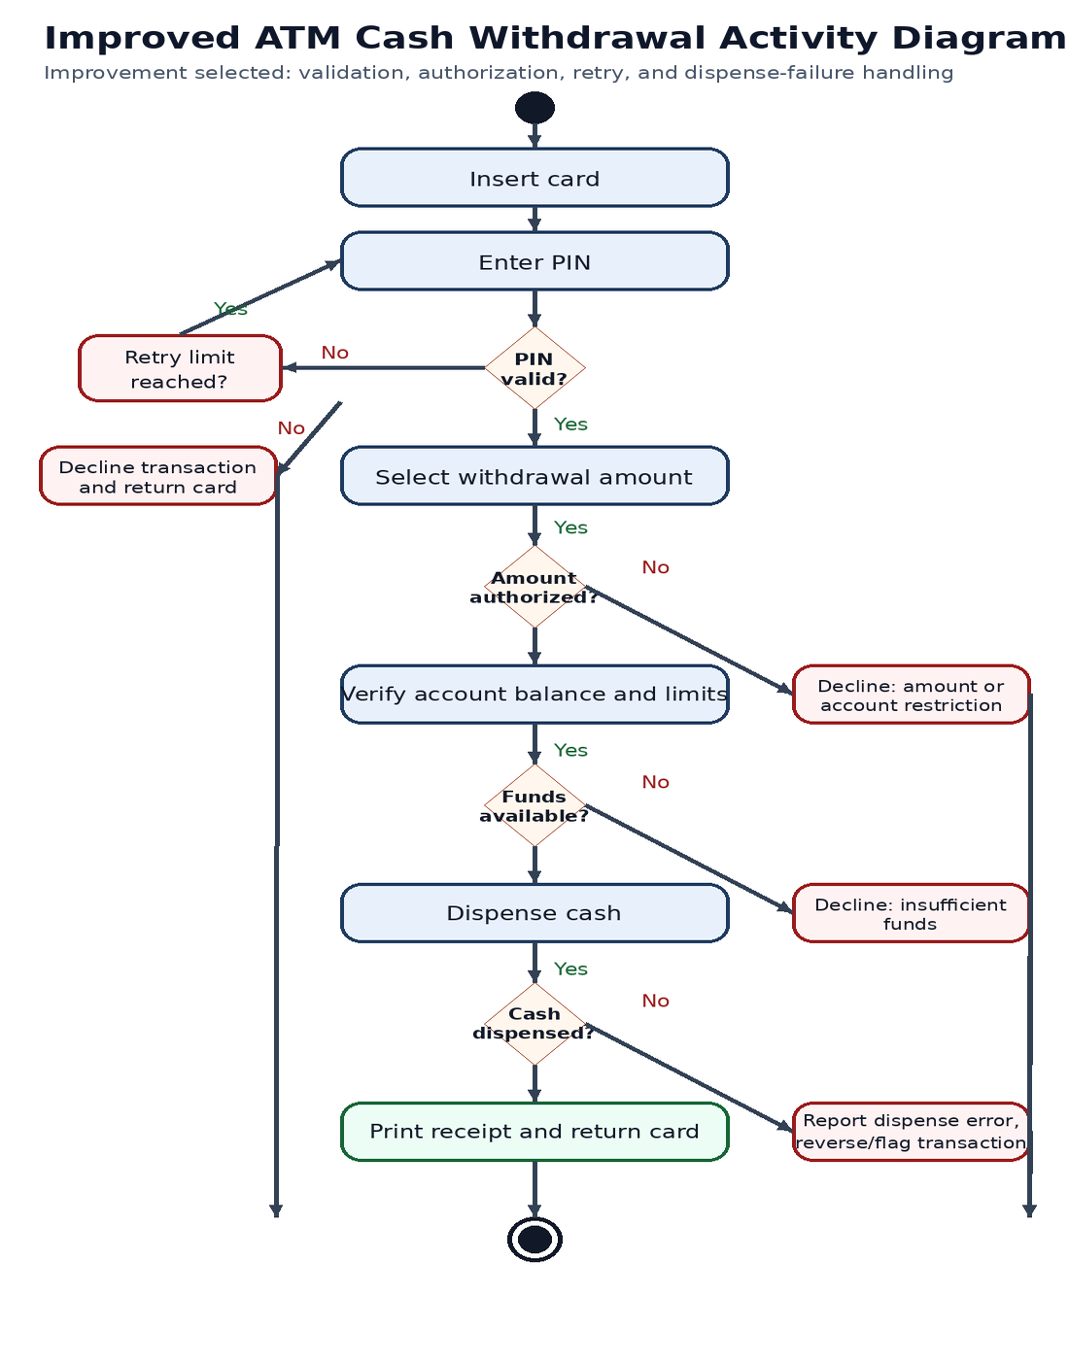
Figure 1. Improved ATM cash withdrawal activity diagram

How the Revised Logic Improves the Design
The revised activity flow prevents the ATM from dispensing cash based only on a valid PIN. It requires the requested amount to be authorized and the account to have sufficient available funds. It also makes unsuccessful outcomes visible: a user can retry a PIN until the limit is reached, receive a decline for an unauthorized amount or insufficient funds, and receive an error or reversal path if the cash dispenser does not confirm delivery. The successful path ends by printing a receipt and returning the card, which provides a complete and secure session.

